DIY Balancing Skateboard

I remember years ago seeing ads while I was scrolling through Instagram for an electric skateboard that balances on one central motorized wheel, aptly named ‘OneWheel’. I was shocked when I clicked the link and saw the price, and promptly filed the dream of owning one away. Later on when I got to college, my roommate brough two of them with him. He let me borrow his smaller one for just a few days, and I was hooked. I wanted one badly, but I still couldn’t justify the price.
I had built an electric skateboard in middle school so I reasoned that I could probably just build my own version of a OneWheel. I decided that I would attempt to build one, and worst case I end up with a bunch of parts that I could use to build another project. I started as I always do – research, research, research. This led me to exactly what I was looking for on a website called Spintend.com. I ended up with a 125A speed controller with a built-in magnetometer and accelerometer to handle the self-balancing. The speed controller, or ESC, runs on an open-source software called VESC and allows for basically infinite ways to control the motor. In my case, I set it up in a “balance” mode which uses a PID controller to keep the board upright based on the input from the onboard sensors. There is a large community built around these motor controllers so it was easy to find PID gains for a good baseline, which I then tuned to my liking later on.
[Insert ‘ow motor test.mp4’ here]
Initial Test of the Motor
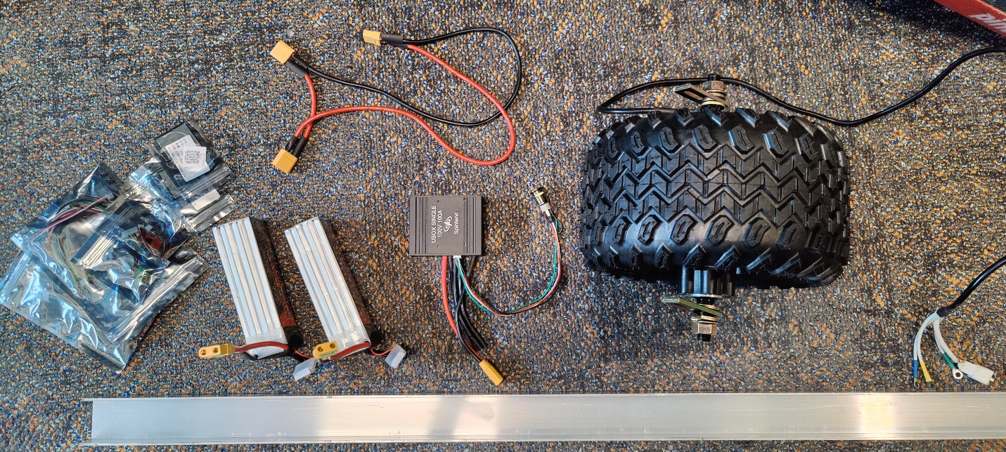
An Array of Parts Scattered on my Dorm Floor
For the chassis of the skateboard itself, I created a CAD model as per usual, utilizing as many off-the-shelf components as possible.
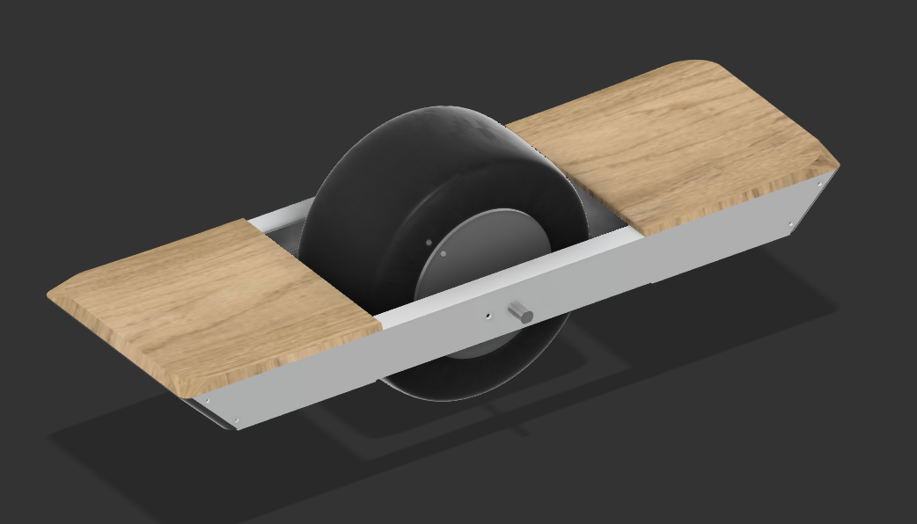
CAD Model of my One-Wheeled Electric Skateboard
I went to the local metal yard and picked up a 6’ length of 1x2 inch aluminum 1/8th wall C-channel. I cut it down according to my cad model and 3D printed the end caps that join the two sides. I also marked and drilled holes for the motor shaft and the power button, while using self-tapping sheet metal screws to hold everything else on.
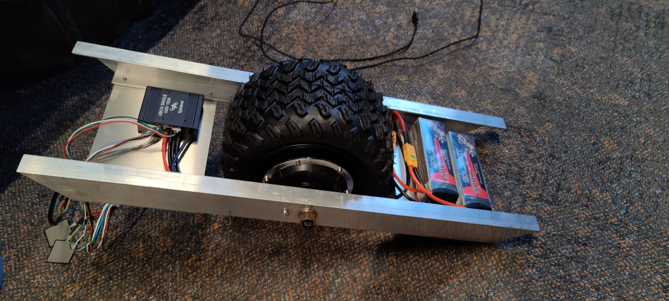
In-Progress Picture of the Assembly
[insert ‘ow test vid.mp4’ here]
Initial Test of the Board
The pads for my feet were simple rectangles cut out of half inch plywood with a radius sanded into the corners. I mounted large pressure sensors to the front foot pad so the board could recognize when I am on it and when I wish to stop by lifting my front heel. This turned out to be a very fun and successful project in the end and I still use it to get around! For the first couple months of riding it around campus, I got stopped countless times by people wanting to know what it was, how I made it, or wanting to try it.

[insert ‘ow final ride.mp4’ here]
First Ride of the Board Around Campus

